786
Name: Muhammad Sherjeel Akhtar
Roll No: 20P-0101
Submitted To
Respected Ma’am:
Miss Hurmat Hidayat
Section: BCS-5B

Task: Sharing files between two Pc’s using via LAN cable.
Answer:
Initial Step
First we connect both the PC’s with the LAN cable.
First PC Set-up
Then we open Network and Internet and over there we go to Network and Sharing Center.
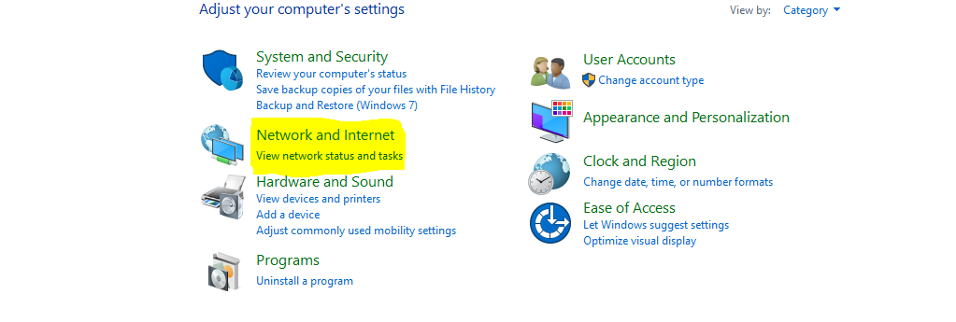
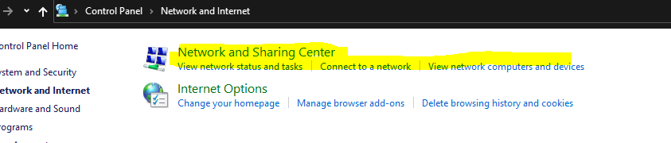
Then we go on change advanced sharing settings and turn on sharing.
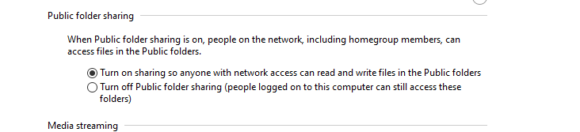
When we connect the both pc we get this interface.
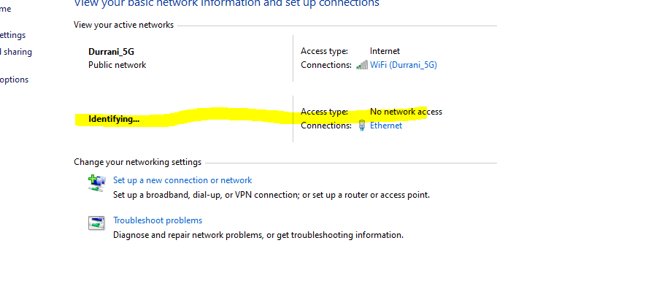
As we can see it is unidentified.
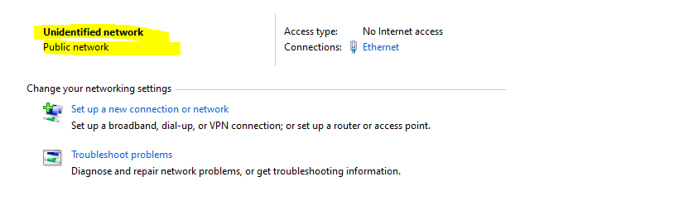
So IPV4 has no internet access.
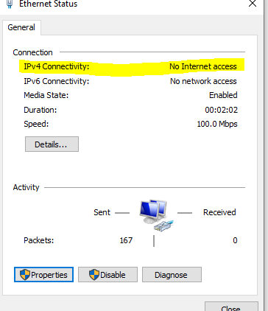
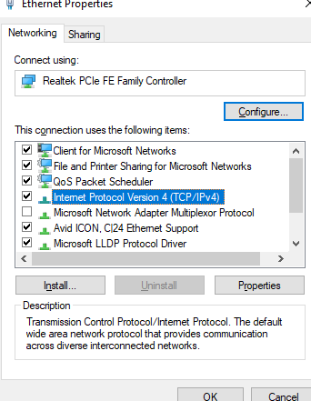
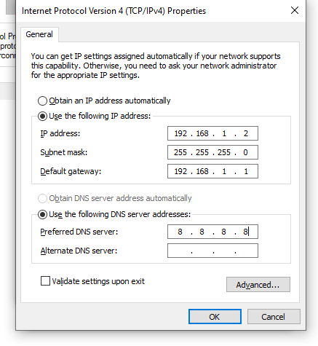
then click on ok and save.
Then we go to Local Disk C and go to users and go to private folder and right click and go on give access to specific people and over there we add everyone and change permission level to read/write
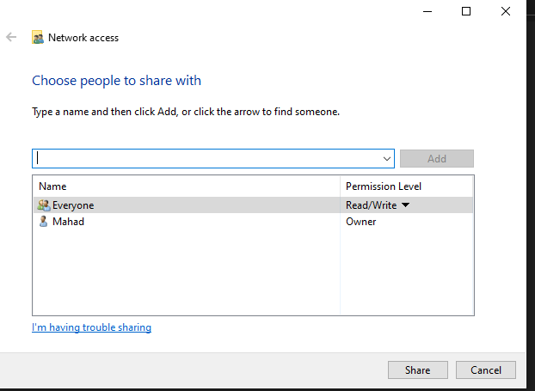

Second PC:
We follow the same steps mentioned above but the difference is we change the IP address and default gateway.

Now we open Network Folder and we can see Two
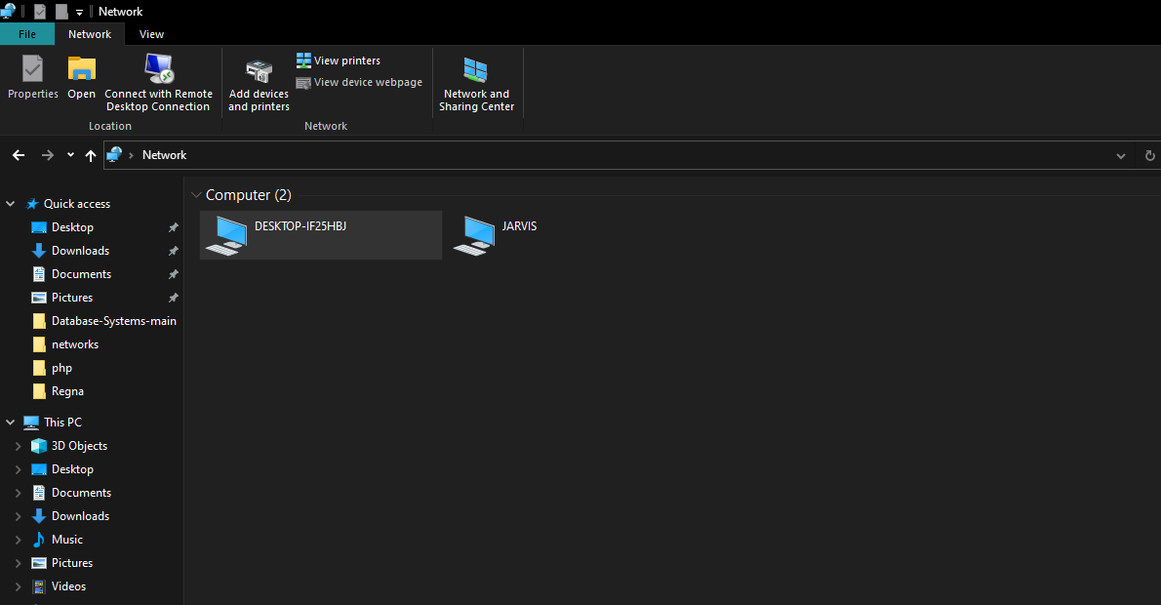
And when we open desktop we see the user name.
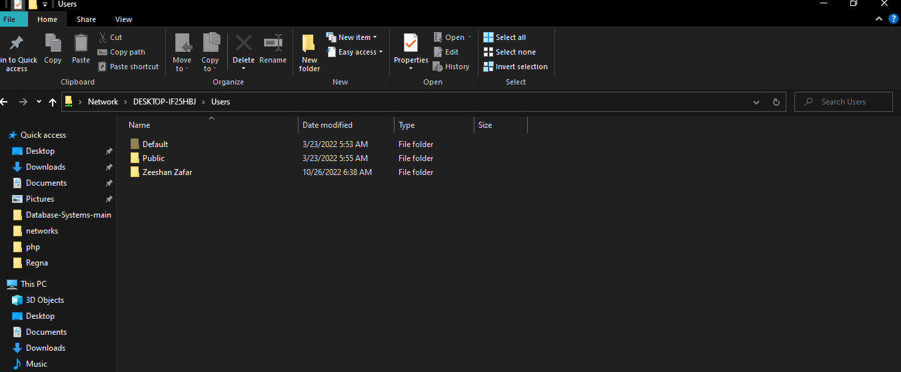

Now we can share files:
So we go on pc 1 and go to accounts data folder and copy acc file.
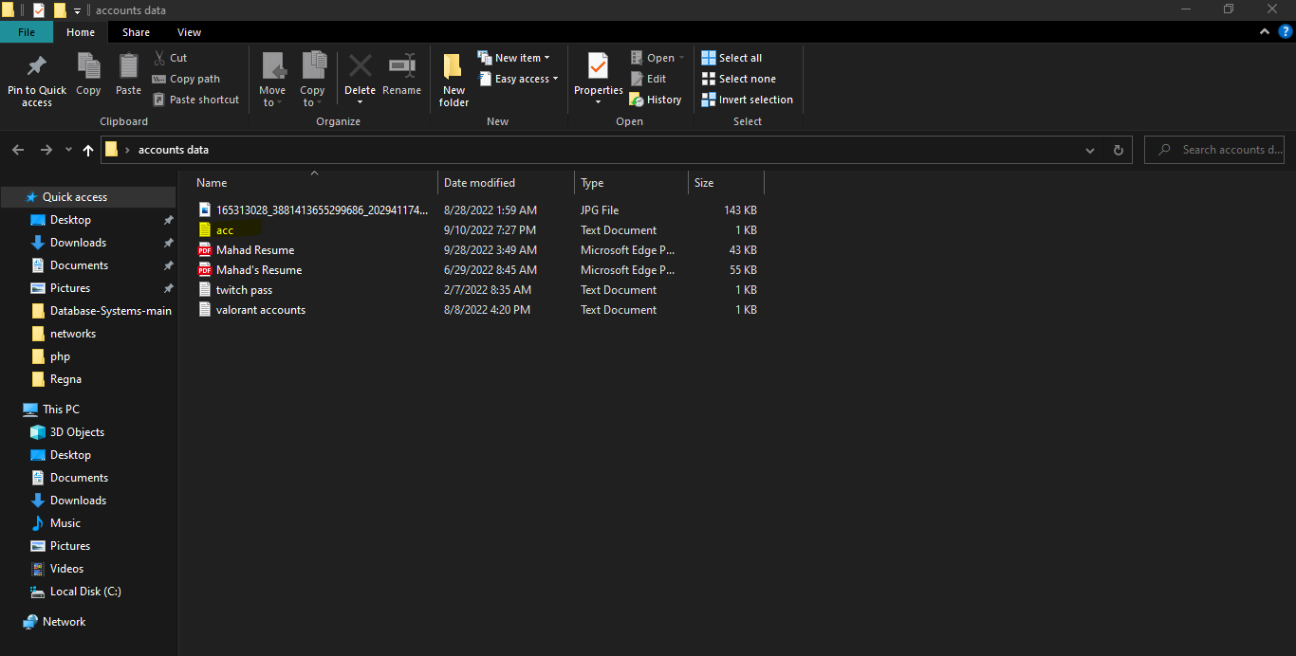
Then we go to networks and go to pc2 user and go Desktop and paste the file.
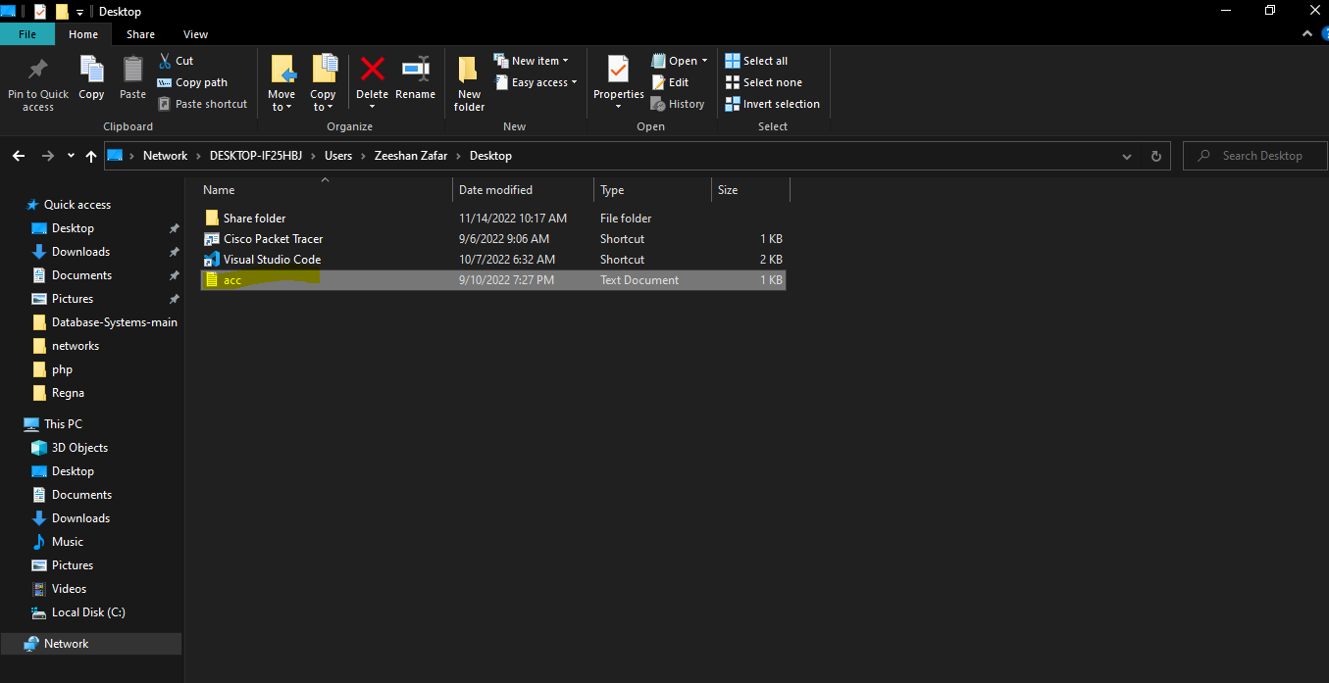
Second PC Desktop view:
